15BCE0517

M.S.SANJAY

a)

Circuit diagram:-

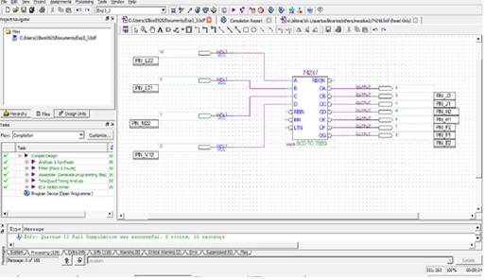

TRUTH TABLE:

|  |  |  |  |  |  |  |  |  |  |  |
| --- | --- | --- | --- | --- | --- | --- | --- | --- | --- | --- |
| W | X | Y | Z | a | b | c | d | e | f | G |
| 0 | 0 | 0 | 0 | 0 | 0 | 0 | 0 | 0 | 0 | 1 |
| 0 | 0 | 0 | 1 | 1 | 0 | 0 | 1 | 1 | 1 | 1 |
| 0 | 0 | 1 | 0 | 0 | 0 | 1 | 0 | 0 | 1 | 0 |
| 0 | 0 | 1 | 1 | 0 | 0 | 0 | 0 | 1 | 1 | 0 |
| 0 | 1 | 0 | 0 | 1 | 0 | 0 | 1 | 1 | 0 | 0 |
| 0 | 1 | 0 | 1 | 0 | 1 | 0 | 0 | 1 | 0 | 0 |
| 0 | 1 | 1 | 0 | 0 | 1 | 0 | 0 | 0 | 0 | 0 |
| 0 | 1 | 1 | 1 | 0 | 0 | 0 | 1 | 1 | 1 | 1 |
| 1 | 0 | 0 | 0 | 0 | 0 | 0 | 0 | 0 | 0 | 0 |
| 1 | 0 | 0 | 1 | 0 | 0 | 0 | 0 | 1 | 0 | 0 |
| 1 | 0 | 1 | 0 | X | X | X | X | X | X | X |
| 1 | 0 | 1 | 1 | X | X | X | X | X | X | X |
| 1 | 1 | 0 | 0 | X | X | X | X | X | X | X |
| 1 | 1 | 0 | 1 | X | X | X | X | X | X | X |
| 1 | 1 | 1 | 0 | X | X | X | X | X | X | X |
| 1 | 1 | 1 | 1 | X | X | X | X | X | X | X |

b) Design a circuit to display thrice of a number on seven segment display (Consider maximum input number to be 2 bit)

AIM:

TO design a circuit to display thrice of a number on seven segment display

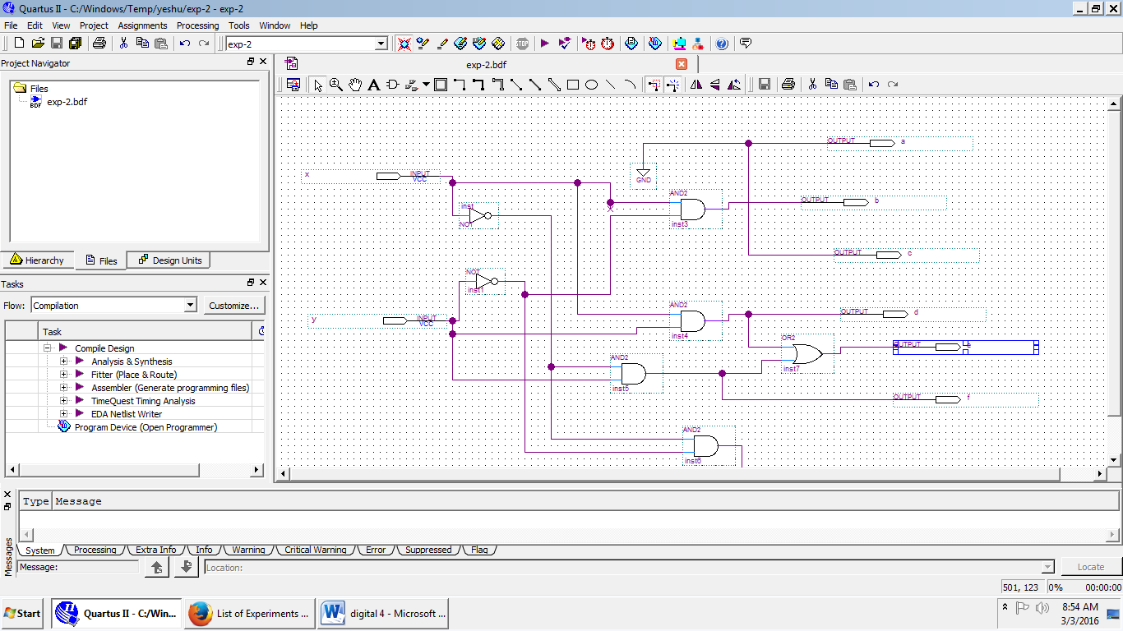

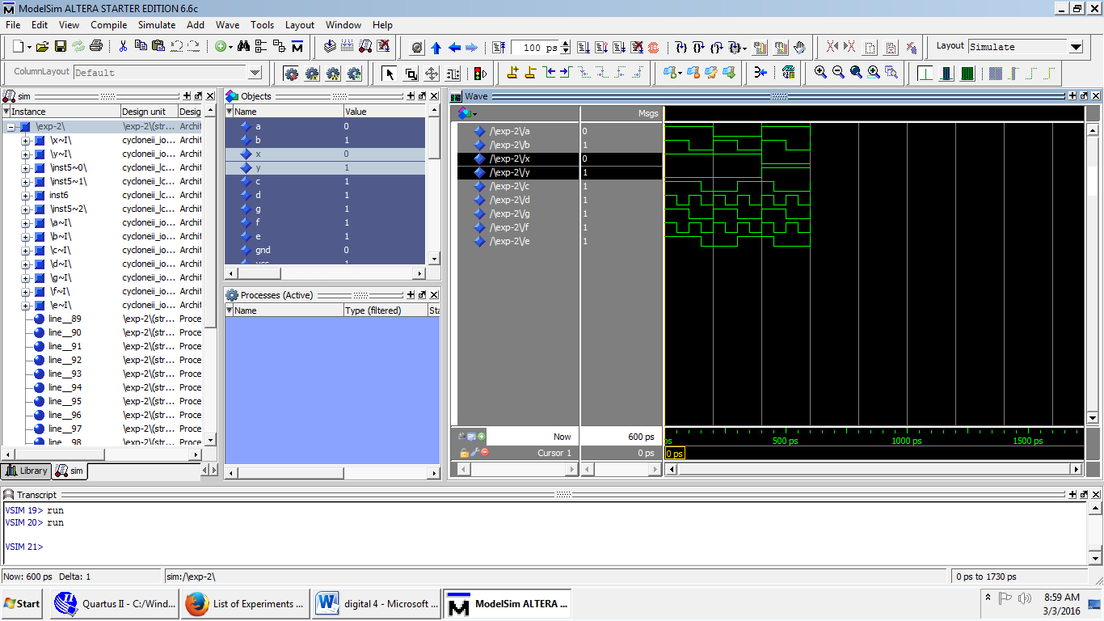

TRUTH TABLE:-

|  |  |  |  |  |  |  |  |  |
| --- | --- | --- | --- | --- | --- | --- | --- | --- |
| X | Y | A | B | C | D | E | F | G |
| 0 | 0 | 0 | 0 | 0 | 0 | 0 | 0 | 1 |
| 0 | 1 | 0 | 0 | 0 | 0 | 1 | 1 | 0 |
| 1 | 0 | 0 | 1 | 0 | 0 | 0 | 0 | 0 |
| 1 | 1 | 0 | 0 | 0 | 1 | 1 | 0 | 0 |

A=0;

B=XY’;

C=0;

D=XY;

E=X’Y+XY=Y;

F=X’Y;

G=X’Y’;

c)Design a combinational circuit which converts 2 4 2 1 code to 8 4 -2-1 code.

Aim:

To design a combinational circuit which converts 2 4 2 1 code to 8 4 -2-1 code.

Truth table:

|  |  |  |  |  |  |  |  |  |
| --- | --- | --- | --- | --- | --- | --- | --- | --- |
| Digits | A | B | C | D | W | X | Y | Z |
| 0 | 0 | 0 | 0 | 0 | 0 | 0 | 0 | 0 |
| 1 | 0 | 0 | 0 | 1 | 0 | 1 | 1 | 1 |
| 2 | 0 | 0 | 1 | 0 | 0 | 1 | 1 | 0 |
| 3 | 0 | 0 | 1 | 1 | 0 | 1 | 0 | 1 |
| 4 | 0 | 1 | 0 | 0 | 0 | 1 | 0 | 0 |
| 5 | 1 | 0 | 1 | 1 | 1 | 0 | 1 | 1 |
| 6 | 1 | 1 | 0 | 0 | 1 | 0 | 1 | 0 |
| 7 | 1 | 1 | 0 | 1 | 1 | 0 | 0 | 1 |
| 8 | 1 | 1 | 1 | 0 | 1 | 0 | 0 | 0 |
| 9 | 1 | 1 | 1 | 1 | 1 | 1 | 1 | 1 |

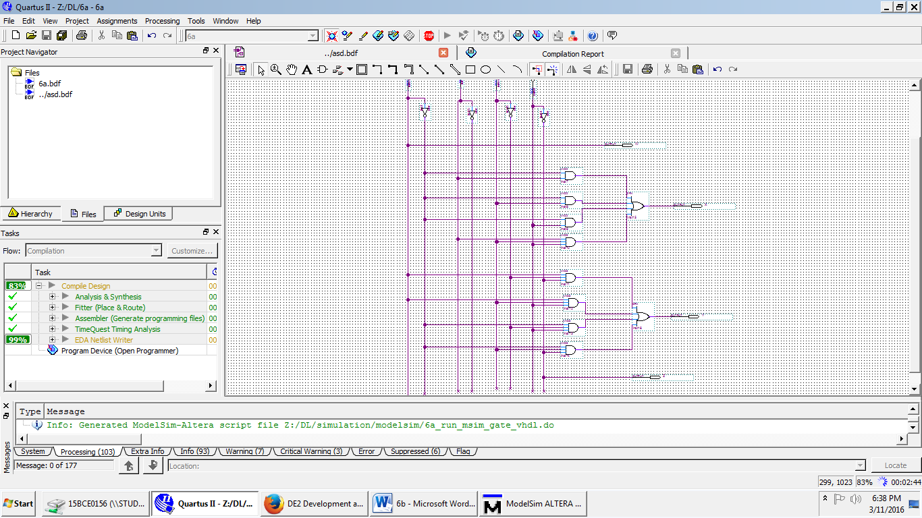

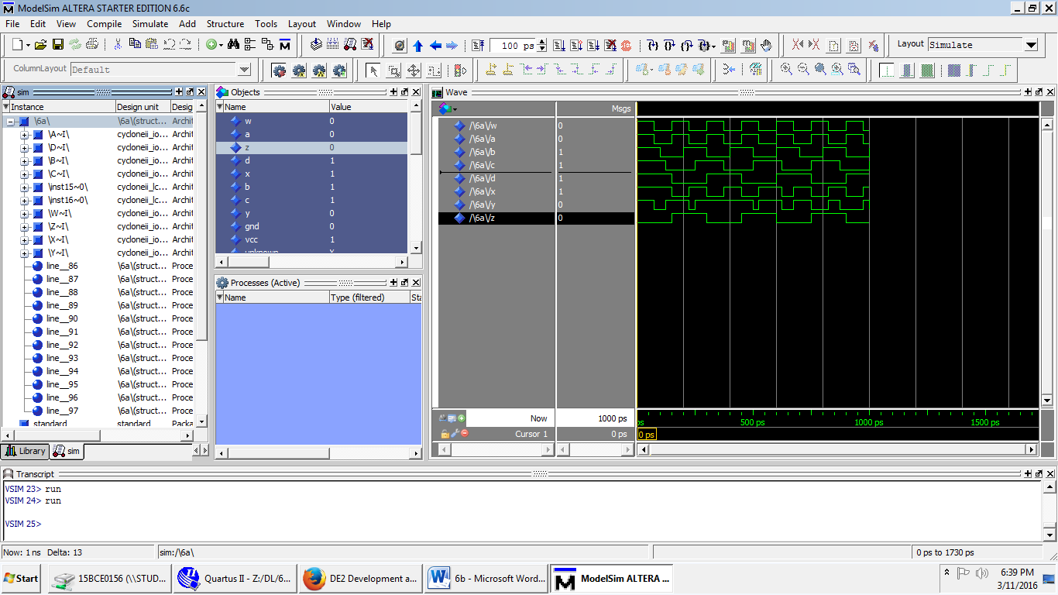

6D)A circuit has four inputs RSTU and four outputs VWYZ. RSTU represents a binary coded decimal digit. VW represents the quotient and YZ the remainder when RSTU is divided by 3(VW and YZ represent 2-bit binary numbers). Assume that invalid inputs do not occur. Design a code converter which converts RSTU to VWYZ.

AIM:

To design acode converter which converts RSTU to VWYZ.

